Graduate Project One Page Memo Report
Student: Yu Ting Chiu
ELECENG: 410/410G
- An introduction telling what you are doing.
I am writing Matlab code to remove the unwanted tones from the original wav file. By finding the unwanted tones and using filters to remove the tones, it will reveal the sound in the new wav file instead of just hearing the noise.

- A summary of what you did.
  - Read Audio and Plot Spectrogram (knowing the range of the unwanted tones)
  - Apply FFT and Identify Frequency Peaks (transform to frequency domain by using FFT and finding the peak frequency)
  - Convert Frequencies to Digital Frequencies(ω) (ω remains in 0-2pi)
  - Design Three FIR Notch Filters
  - Apply Filters
  - Combine Filters into One (using function conv() to combined as one filter)
  - Plot Spectrogram of Filtered Signal
  - Normalize Audio to Prevent Clipping (Normalizes the signal to ensure that no sample exceeds [-1, 1] before writing to file.)
  - Frequency Response of Filter(additional)
Frequency | Digital Frequency | A
1574.9868 Hz | 0.897590 rad/sample | -1.246991
3149.9735 Hz | 1.795181 rad/sample | 0.445012
4724.9603 Hz | 2.692771 rad/sample | 1.801918
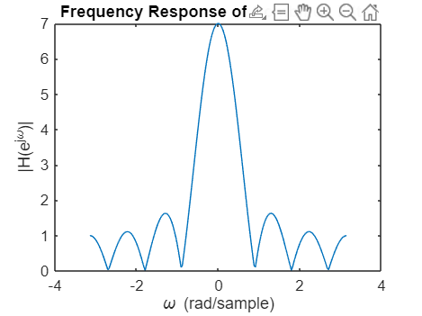
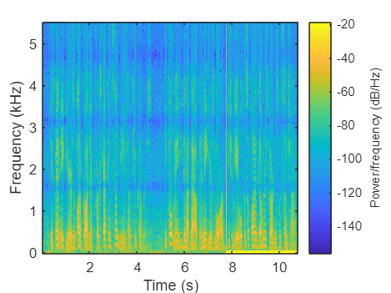

- This project deepens my understanding of frequency domain analysis. I think it helps me reinforce the concept of digital filtering and frequency detection.
- This project strengthens my skills in Matlab with practical signal processing.

